EXPT NO: 3 | IMPLEMENTATION OF CONVOLUTIONAL NEURAL NETWORKS (CNNs) FOR IMAGE CLASSIFICATION
DATE: 10-08-2026

PRE-LAB QUESTIONS (PROVIDE BRIEF ANSWERS TO THE FOLLOWING QUESTIONS)
- What is a Convolutional Neural Network (CNN)?
A Convolutional Neural Network (CNN) is a deep learning model mainly used for image processing and computer vision. It automatically learns features such as edges, shapes, and objects from images using convolutional layers.

- What are the functions of convolution and pooling layers in a CNN?
• Convolution layer: Extracts important features such as edges, textures, and patterns from an image.
• Pooling layer: Reduces the spatial size of feature maps, decreasing computation and helping the model focus on important features
.
- Differentiate between image classification and object detection.
Image Classification: Identifies the category or class of the entire image. Example: cat or dog.
Object Detection: Identifies objects and also determines their locations using bounding boxes. Example: detecting multiple cars and their positions in an image.

- Why is image preprocessing important before training a CNN model?
Image preprocessing improves the quality and consistency of input data. Operations such as resizing, normalization, and data augmentation help the CNN learn efficiently, reduce overfitting, and improve classification accuracy.

- What are the advantages of using benchmark datasets such as CIFAR-10 or Kaggle image datasets.
Benchmark datasets provide standardized and well-organized data for training and testing models. They make it easier to compare different CNN architectures, evaluate model performance, and reproduce experimental results.

AIM
To design, implement, and evaluate a Convolutional Neural Network (CNN) for image classification using a benchmark image dataset.

SOFTWARE REQUIREMENTS
- Python
- TensorFlow/Keras or PyTorch
- Google Colab
- Matplotlib
- Kaggle Dataset (e.g., CIFAR-10, Cats vs Dogs, Intel Image Classification)

OBJECTIVES
Students will be able to:
- Understand the architecture of Convolutional Neural Networks.
- Implement a CNN model for image classification.
- Train and evaluate a CNN using a real-world image dataset.
- Visualize training and validation performance.
- Analyze the effectiveness of CNNs for image recognition tasks.

PROCEDURE
PART A: DATASET PREPARATION
- Perform the following tasks:
- Download an image dataset from Kaggle or use CIFAR-10.
- Load the dataset.
- Preprocess images by resizing and normalization.
- Split the dataset into training, validation, and testing sets.

PART B: CNN MODEL IMPLEMENTATION
Build a CNN model consisting of:
- Convolution layers
- ReLU activation
- Max Pooling layers
- Fully Connected layers
- Softmax output layer

Compile the model using:
- Appropriate optimizer
- Cross-entropy loss function

PART C: MODEL TRAINING AND EVALUATION
Train the CNN model.
Record:
- Training accuracy
- Validation accuracy
- Training loss
- Validation loss
- Testing accuracy
Plot:
- Accuracy vs Epoch
- Loss vs Epoch

PART D: PERFORMANCE ANALYSIS
Analyze:
- Classification accuracy
- Confusion Matrix
- Sample predictions
- Misclassified images
Discuss the strengths and limitations of CNNs for image classification.

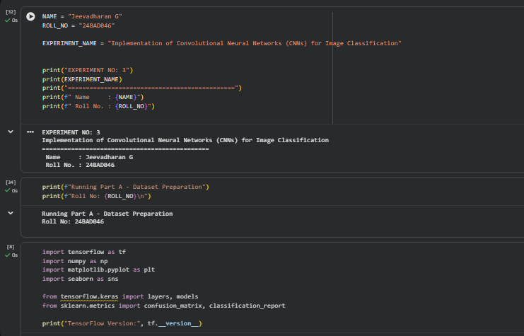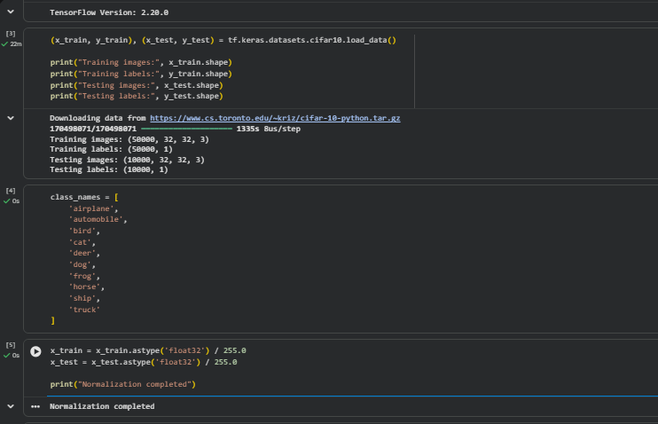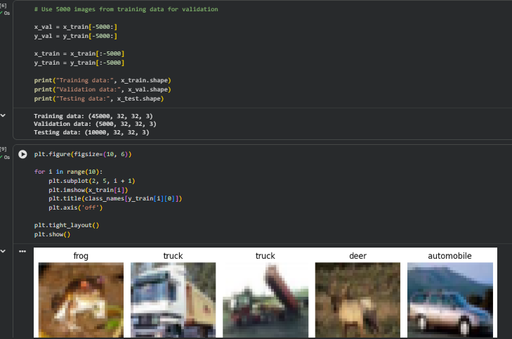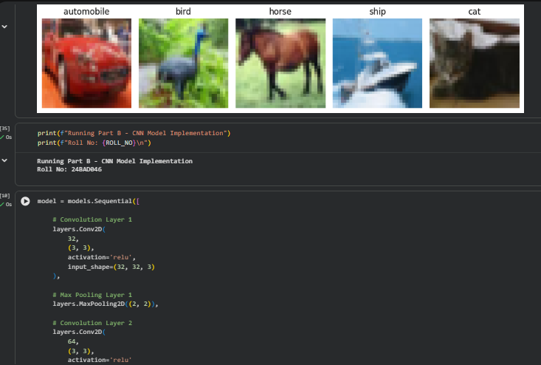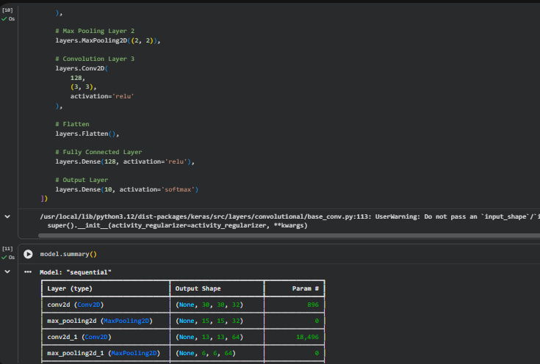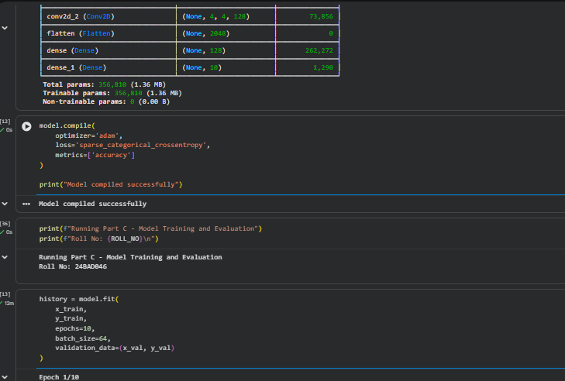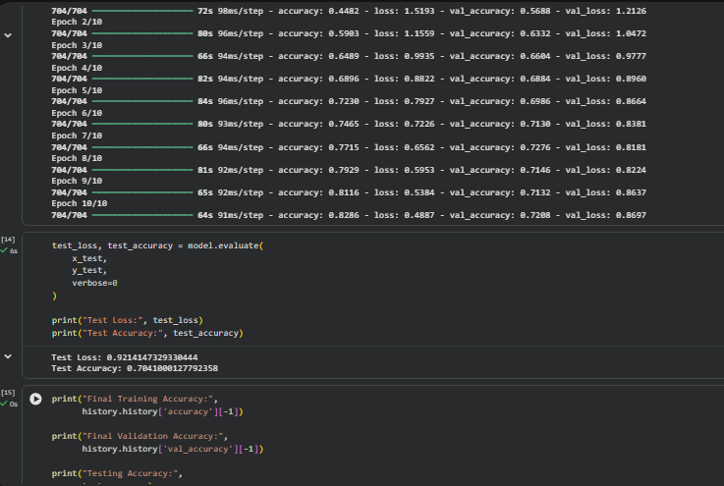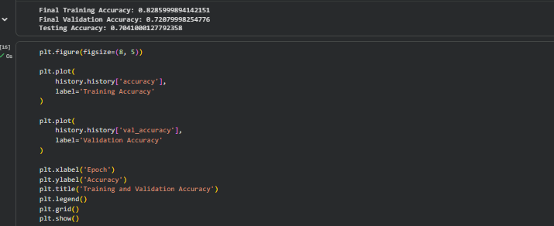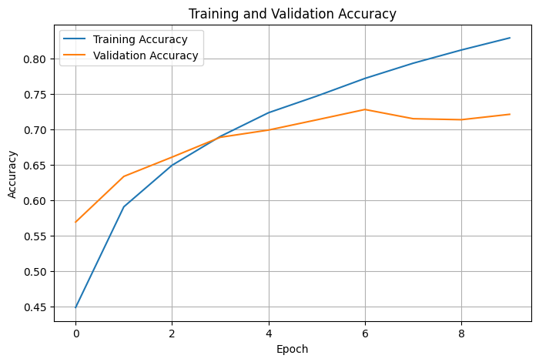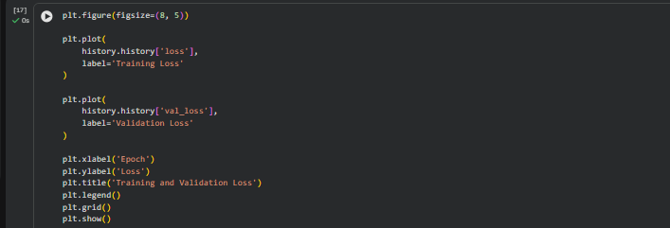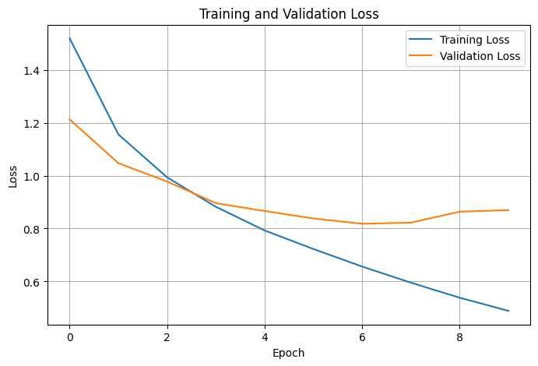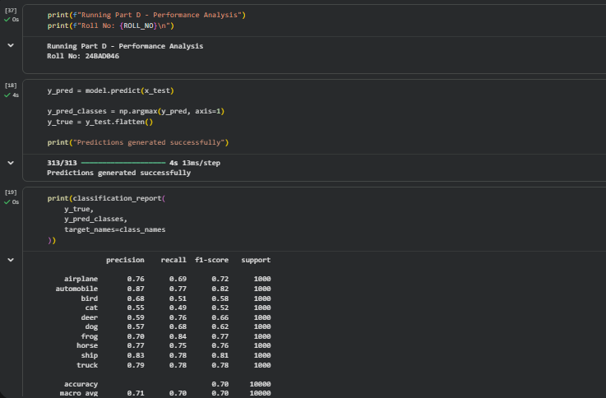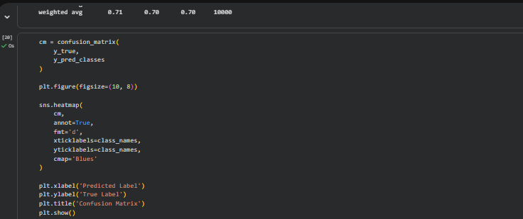
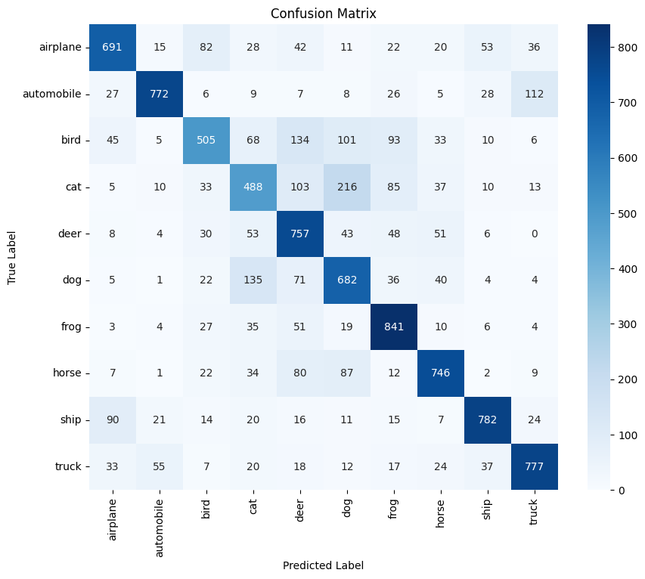
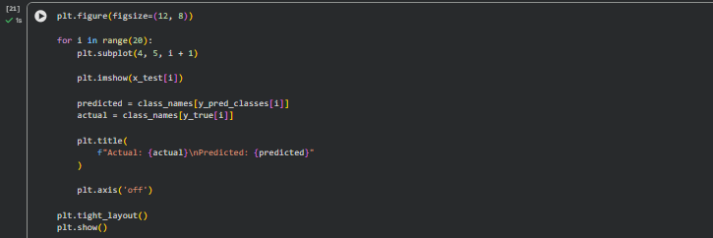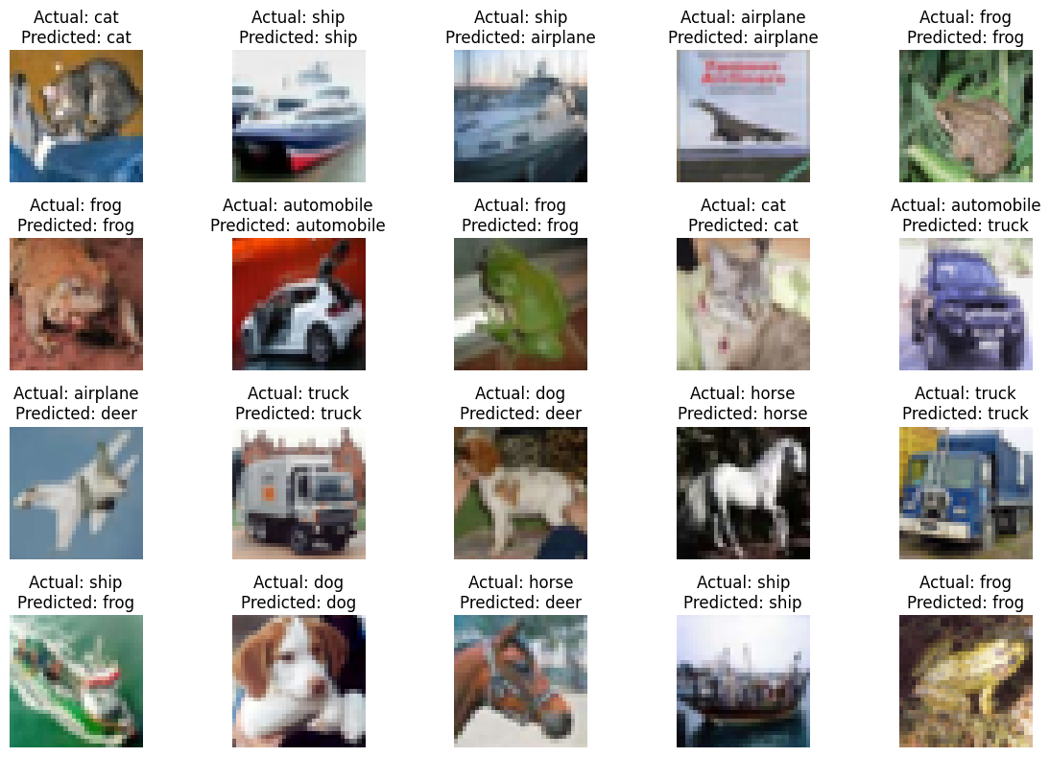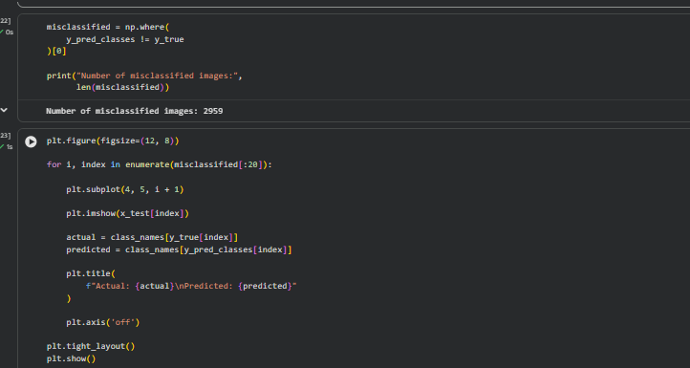
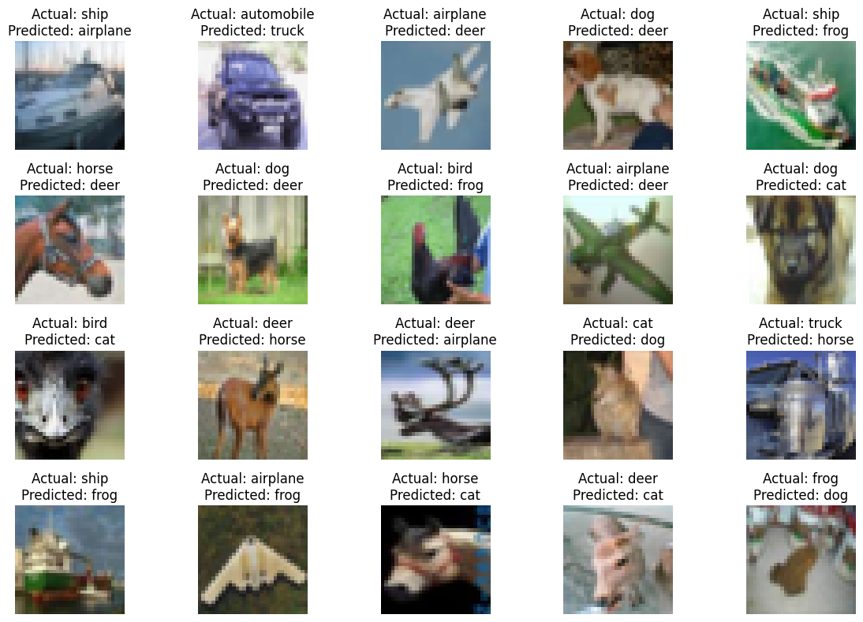
EXPECTED OUTCOME
Students will gain practical experience in designing, training, and evaluating CNN models for image classification and understand how CNN architecture influences classification performance.

POST-LAB QUESTIONS (PROVIDE BRIEF ANSWERS TO THE FOLLOWING QUESTIONS)
- Why are convolution layers more effective than fully connected layers for image processing?
Convolution layers preserve the spatial relationships between pixels and use shared weights to detect local features. This requires fewer parameters than fully connected layers, making them more efficient for image processing.

- How does Max Pooling improve CNN performance?
Max Pooling reduces the size of feature maps by selecting the maximum value from a small region. It reduces computational complexity, decreases the number of parameters, and makes the model more robust to small changes in object position.

- Which hyperparameters significantly affected your CNN model performance?
Important hyperparameters include:
- Learning rate
- Batch size
- Number of epochs
- Number of convolutional layers
- Number of filters
- Kernel size
- Dropout rate
Among these, the learning rate, number of layers, filters, and epochs can significantly affect accuracy and training performance.

- What challenges did you encounter while training the CNN model?
Common challenges include overfitting, long training time, low accuracy, selecting suitable hyperparameters, and insufficient training data. Choosing the right architecture and preprocessing techniques can help overcome these problems.

- Suggest two improvements that can increase the classification accuracy of your CNN.
Two effective improvements are:
- Use data augmentation such as rotation, flipping, and zooming to increase the diversity of training images.
- Tune the CNN architecture and hyperparameters, such as increasing suitable convolutional layers/filters and optimizing the learning rate.

ASSESSMENT
Description | Max Marks | Marks Awarded
Pre Lab Exercise | 5
In Lab Exercise | 10
Post Lab Exercise | 5
Viva | 10
Total | 30
Faculty Signature

